The Bletchley Game

*Vocational School for Computer Programming and innovation*

A project by:

Team - HeartOfTheCode

Contents

1. Our Team 2

2. Purpose of the project 2

3. Main functions description 3

4. Block diagram 3

5. Used technology 5

6. Future of the project 5

7. Overview 5

# Our Team

Scrum trainer:

Afra Yusrefova - [AFYusrefova18@codingburgas.bg](mailto:AFYusrefova18@codingburgas.bg)

Developers:

**Back end:**

Kaloqn Dinev - [kddinev18@codingburgas.bg](mailto:kddinev18@codingburgas.bg)

**Front end:**

RenetaTopalska - [RBTopalska18@codingburgas.bg](mailto:RBTopalska18@codingburgas.bg)

Quality engineer:

Svetlana Boyadzhieva - [SVBoyadzhieva18@codingburgas.bg](mailto:SVBoyadzhieva18@codingburgas.bg)

Documentary work:

Emily Kehayova – [EDKehayova18@codingburgas.bg](mailto:EDKehayova18@codingburgas.bg)

# Purpose of the project

The purpose of the game we developed is to help the codebreakers to find out the coordinates of the German battleship so the allies can track and destroy them before they attack us. Our project is profitable, entertaining and thought-provoking.

# Main functions description

|  |  |  |
| --- | --- | --- |
| Name | Purpose | Arguments |
| void numberGenerator | Generate 4 random numbers from 1 to 7 | Number[], hardOrEs |
| void sortNumbers | Sorts user’s data input into an increasing order | sortedNumbers[] |
| void checkIfUserDataIsValid |  | No arguments |
| Int checkIfThreAreGuesedNumbers |  | hackerNumbers[], germanNumbers[] |
| Int checkIfThreAreGuesedNumbersAndPosition |  | hackerNumbers[], germanNumbers[] |
| void playerVsPlayer |  | hackerNumbers[], germanNumbers[],hardOrEasy |
| void playerVsComputer |  | hackerNumbers[], germanNumbers[],hardOrEasy |
| bool difficultyMenu | The user chooses the difficulty level | hackerNumbers[], germanNumbers[],humanOrBot |
| bool levelMenu | Shows the different difficulty levels | hackerNumbers[], germanNumbers[] |

# Block diagram

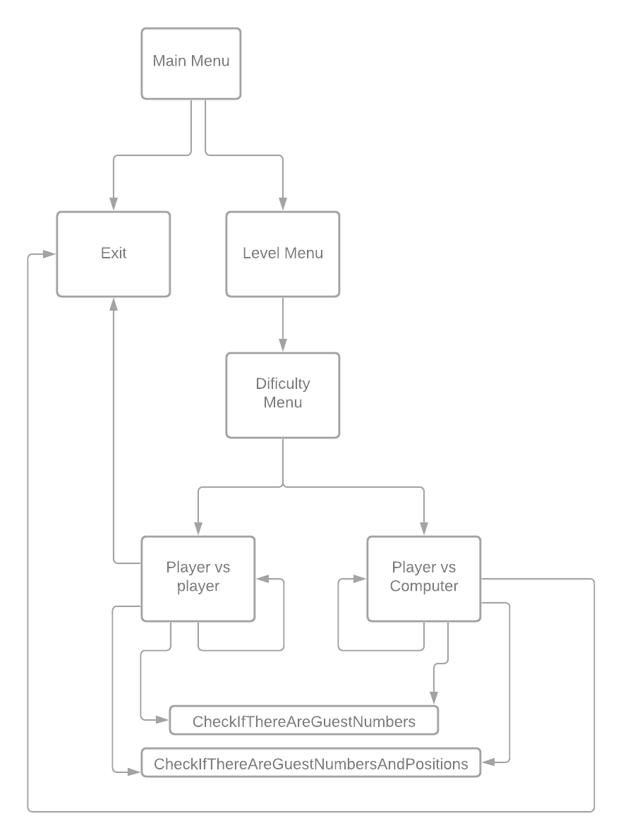

# Used technology

# Future of the project

We are planning to:

1. To export the project in Unity
2. To improve the design of the game
3. To add multiplayer mode

# Overview

We strongly believe that the project our team created is the best we have done so far and we see a lot of possibilities to improve it in the future.